The tableau HR scorecard measuring success in talent management

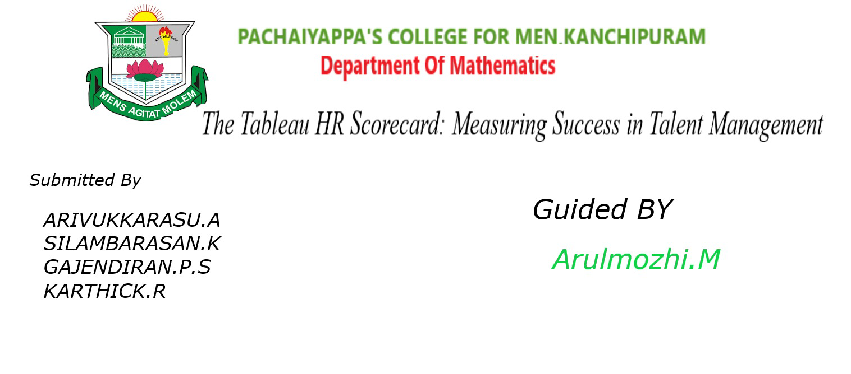

The tableau HR scorecard mea suring success in talent management

• Introduction

• Problem Definition and Design Thinking

• Advantages and Disadvantages

• Ap lications

• Future Scope

• Steps in tableau dashboard and story

• Conclusion

PROBLEM DEFINATION:

In the realm of talent management, organizations often face challenges in quantifying and evaluating the effectiveness of their human resources strategies. The absence of a structured framework for measurement leads to ambiguity in assessing HR initiatives' impact on organizational success. To address this issue, the need for a comprehensive HR scorecard system arises, specifically tailored for tableau implementation.

Empathy map:

We have created the Empathy map by better  
understanding of problem

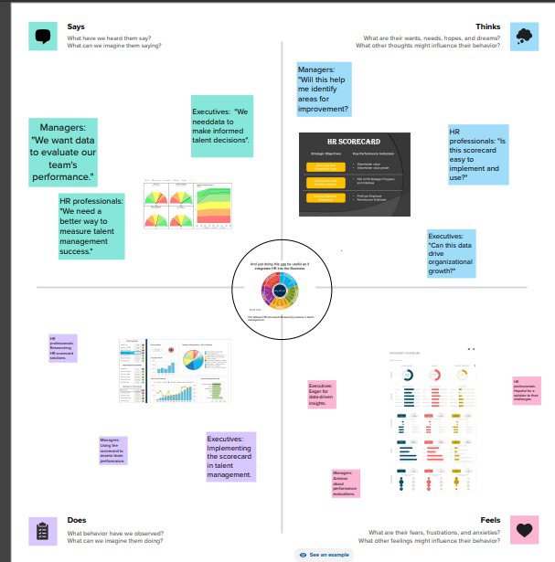

Brainstorm and Idea Prioritization:

As team we pointout the collect ideas as per  
person in the Brainstorm map

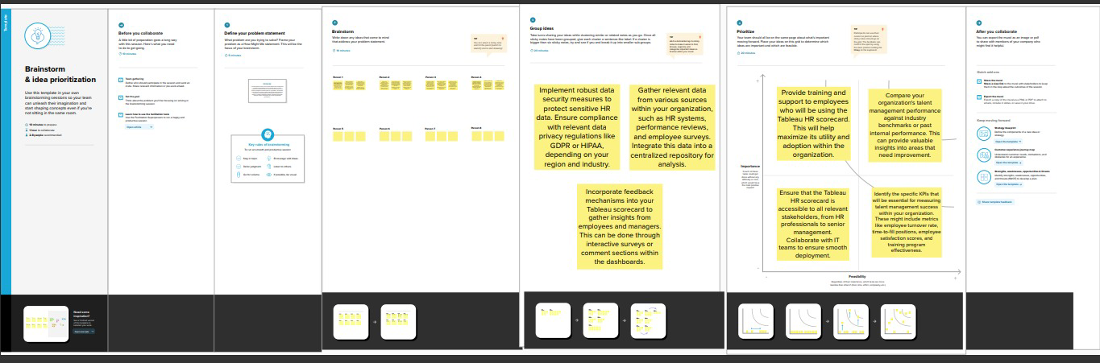

Advantages and Disadvantages:

Advantages:

1.Data Visualization:

Tableau allows HR professionals to create visually appealing and interactive dashboards, making it easier to understand and interpret complex talent management data.

2.Customization:

Users can customize Tableau dashboards according to specific metrics and key performance indicators (KPIs) relevant to their organization, providing a tailored view of talent management success.

3.Real-time Analysis:

Tableau enables real-time data analysis, allowing HR teams to monitor talent management metrics as they change, facilitating quicker decision-making processes.

4.Data Integration:

Tableau can integrate with various data sources, including HR software, allowing HR professionals to consolidate data from different platforms for a comprehensive view of talent management efforts.

Disadvantages:

1.Complexity:

Tableau can be complex for beginners, requiring a learning curve to fully utilize its features. HR staff might need training to make the most out of the tool.

2.Cost:

Tableau licenses can be expensive, especially for organizations with large user bases. Small businesses or non-profits might find it financially burdensome.

3.Data Security:

Integrating sensitive HR data into Tableau requires robust security measures to protect the confidentiality and integrity of employee information, posing a potential security risk if not managed properly.

4.Maintenance:

Tableau dashboards require regular updates and maintenance to ensure they reflect current HR metrics accurately. Failure to update could lead to decision-making based on outdated information.

5.Dependency on Data Quality:

The accuracy of Tableau insights heavily depends on the quality of the input data. Inaccurate or incomplete data can lead to misleading conclusions about talent management success.

Applications:

Measure employee performance against established goals and key performance indicators (KPIs). Visualize individual and team achievements to identify top performers and areas for improvement.

Analyze recruitment data to evaluate the effectiveness of different hiring sources, time-to-fill metrics, and candidate quality. Optimize recruitment strategies based on data insights to attract the right talent.

Future Scope:

Future versions of data visualization tools may incorporate more advanced predictive analytics capabilities. This means organizations can anticipate trends, identify potential issues, and make proactive decisions based on predictive insights.

Integration with artificial intelligence (AI) and machine learning (ML) algorithms could enable automated data analysis. AI-driven insights could provide more detailed and accurate predictions, allowing HR professionals to focus on strategic decision-making.

AR and VR technologies might be integrated into data visualization tools, offering immersive and interactive ways to explore HR data. This could enhance training programs, simulate workplace scenarios, and facilitate better understanding of complex data sets.

Step-1

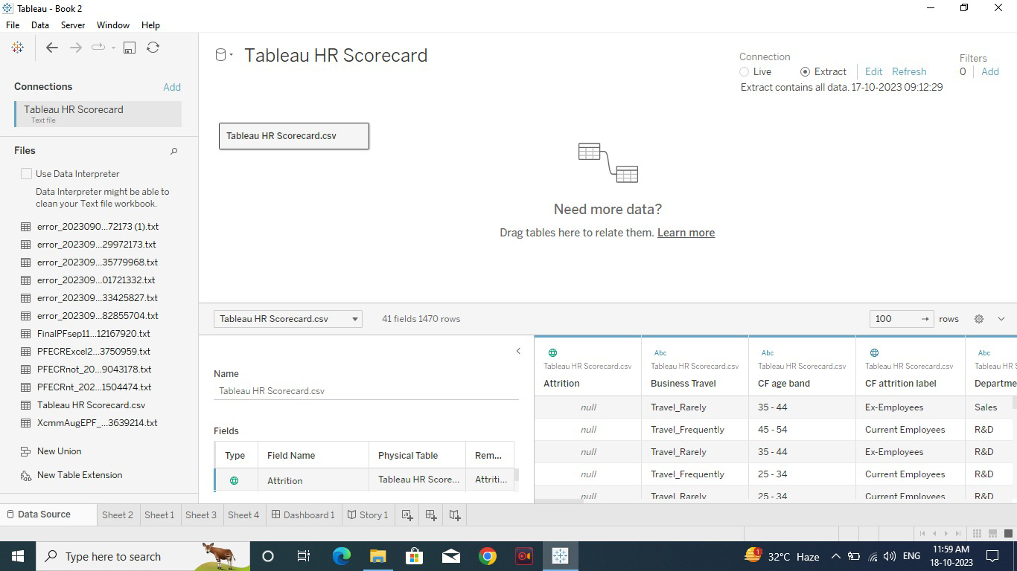

Step-2

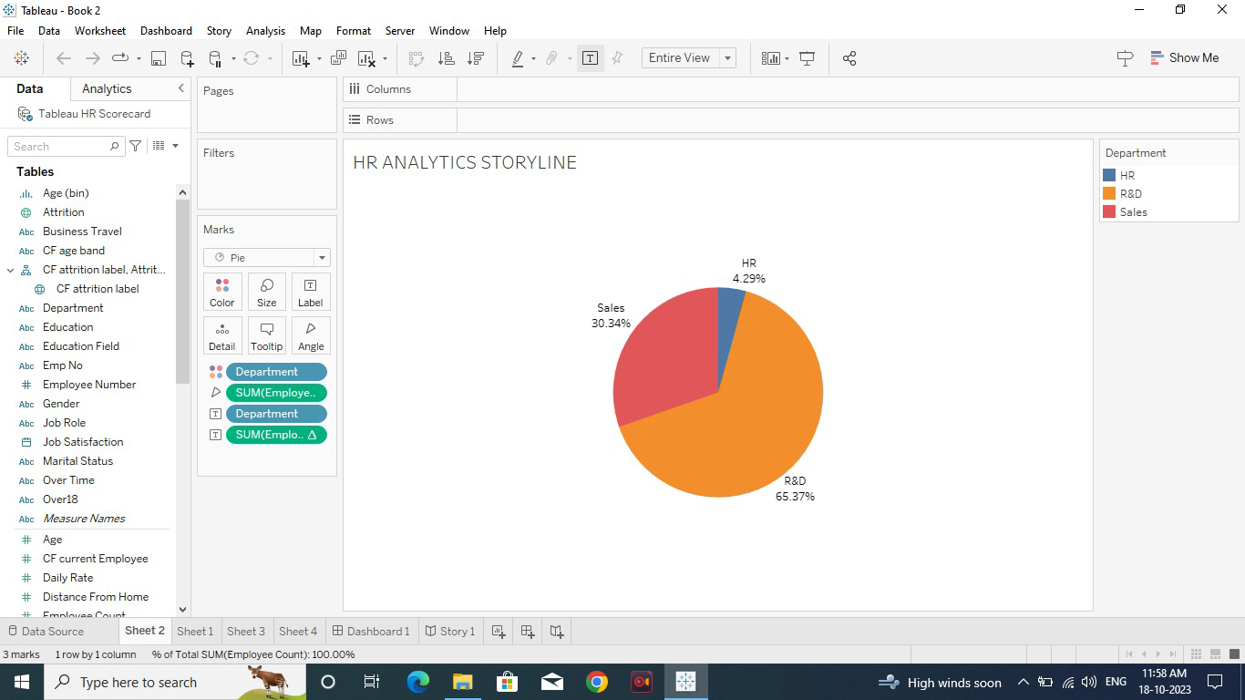

Step-3

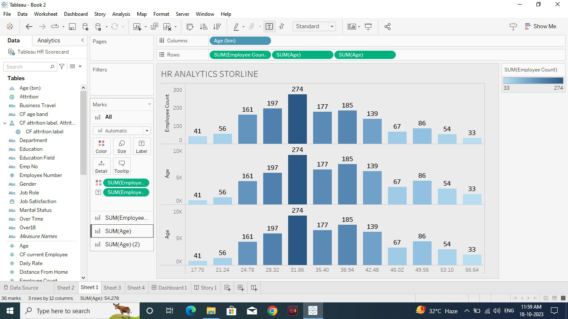

Step-4

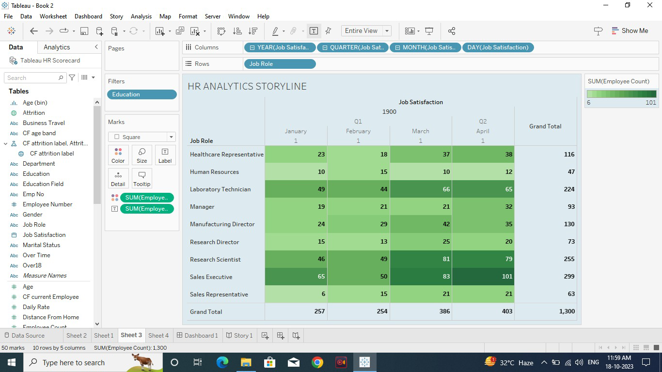

Step-5

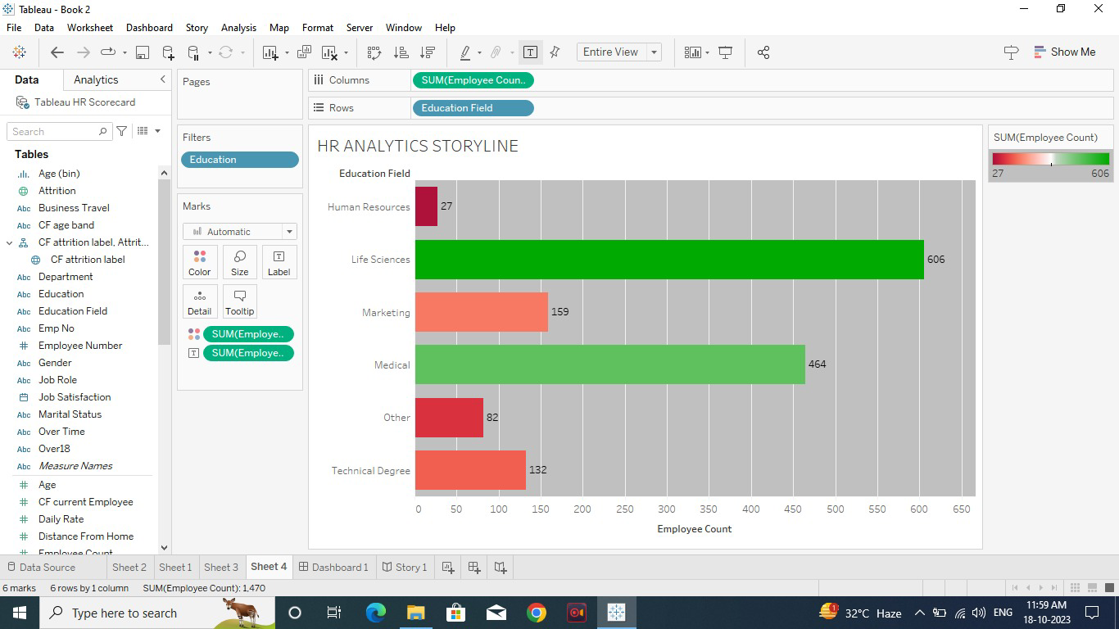

Story-1

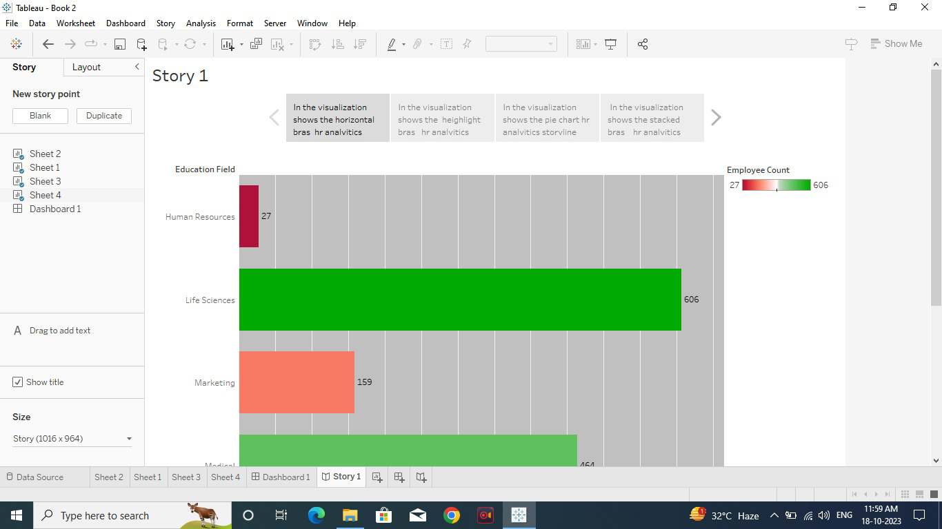

Step-2

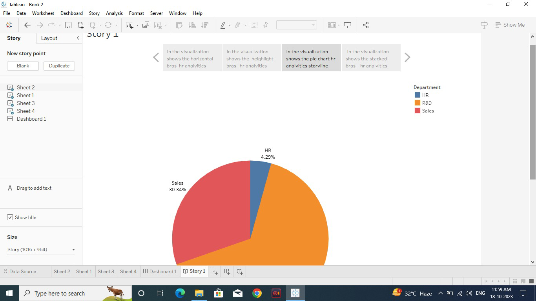

Step-3

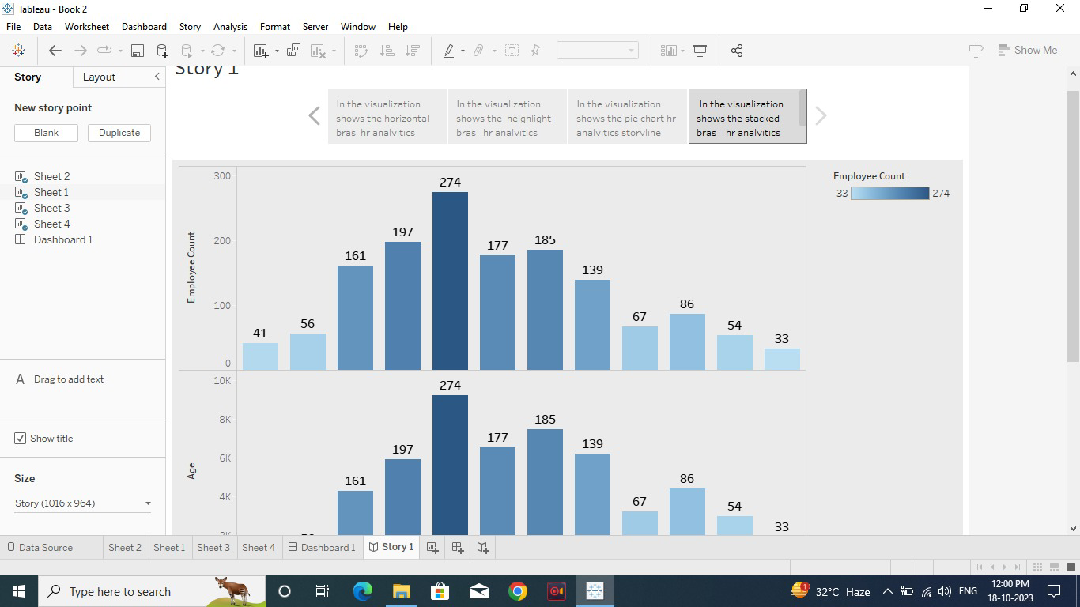

Step-4

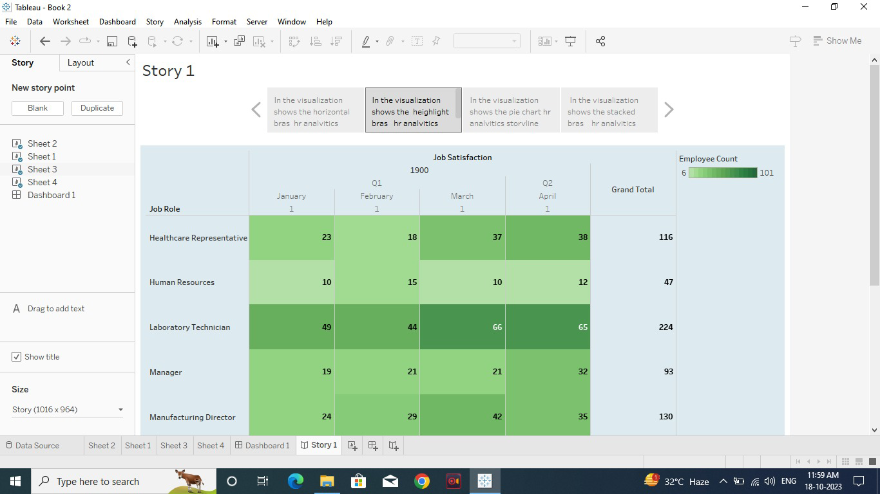

Dashboard:

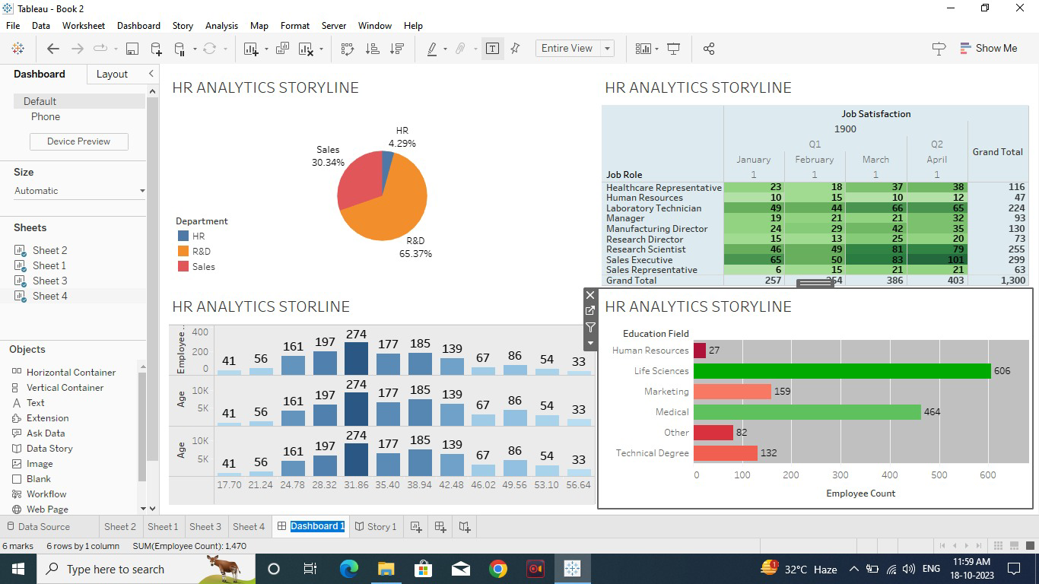

Conclusion:

In conclusion, the future of data visualization tools, including Tableau HR Scorecard, holds immense promise for the field of human resources. As technology continues to evolve, these tools are expected to become more sophisticated, intuitive, and integrated, offering HR professionals powerful capabilities to analyze, interpret, and leverage data for strategic decision-making.With advancements such as advanced predictive analytics, AI integration, augmented reality, and enhanced security measures, data visualization tools are poised to revolutionize HR processes. These developments will empower HR professionals to gain deeper insights into workforce trends, enhance employee engagement, optimize recruitment strategies, and make proactive decisions to foster a more productive and satisfied workforce.Additionally, the future of data visualization tools will likely prioritize customization, mobile optimization, and collaborative features, ensuring that HR professionals can tailor the tools to their specific needs, access insights on-the-go, and collaborate seamlessly with colleagues and stakeholders.In essence, the evolving landscape of data visualization tools represents a significant opportunity for HR professionals to harness the power of data, driving innovation and efficiency in talent management, workforce planning, and organizational development. As organizations embrace these advancements, they are well-positioned to thrive in the dynamic and data-driven future of HR.